MPO 624 Intake Survey
Name, program, year:

Brian Matilla; Meteorology and Physical Oceanography; 1st year.

Advisor and research topic (if applicable):

Dr. Brian Mapes; Our research topic will dive into the analysis of global extreme precipitation events through the use of many interactive pieces of software and models such as WRF and the IDV. We aspire to utilize different case studies of extreme precipitation and determine causality and predictability of such events.

Career goals/ hopes:

My career aspirations are to obtain my Ph.D. in MPO and be able to apply for and obtain a position to work at the National Center for Atmospheric Research. I also would be open to the opportunity of working in academia in some time along the way.

Hopes for this course (please be as specific and detailed as you like, perhaps from the outline above):
Being in this field requires a thorough understanding and application of computer programming fundamentals and techniques to best enhance the effectiveness of future research endeavors. I hope to better on my current skill set while also understanding the “hows and whys” of data analysis in order to further enhance productivity and effectiveness in communication.

Computer system you will work on (Windows, Mac, Linux; RAM if you know):

At Home:
Windows 8.1; 32 GB DDR3 2400 RAM

At RSMAS:
Mac OS X Mavericks; 32 GB DDR3 1600 RAM

Describe your computer experience in narrative form. What are your thoughts, philosophy, worries, hopes about working with computers. Don't try to impress, just show me where we are all at here at the beginning. Read the course goal again.

I’ve explored computers from a young age and have always been naturally curious for finding just one more thing to learn. I see working with computers as a universal language to be learned; an essential piece of the puzzle quite like breathing is to human functionality. However, while the computer age has its positives, I believe it’s also just as critical to maintain a sound knowledge base of the fundamentals before computers were invented, since the concepts are generally intact.

Have you used the command line in a terminal? Yes.
Favorite commands: My favorite commands are nano, gzip/gunzip, and ssh –X/-Y.

Have you edited code? If so, in what editor? I have previously used IDL, NCL, R Script, and MATLAB to edit code.

Favorite or proudest few lines of code (any language):

NCL code (MPEX 2013):
dataOpts@colTemperature = "Red"
dataOpts@colDewPt = "Red"
;dataOpts@colWindP = dataOpts@colTemperature
dataOpts@ThermoInfo = False
dataOpts@Cape = False

skewt_data_YSU = skewT_PlotData (wks, skewt_bkgd, p_YSU, tc_YSU, tdc_YSU, z_YSU, wspd_YSU, wdir_YSU, dataOpts)

draw(skewt_data_YSU)

;-------CAPS QNSE Sounding set-up---------

dataOpts = True
;dataOpts@xpWind = 58
dataOpts@colTemperature = "Gold"
dataOpts@colDewPt = "Gold"
;dataOpts@colWindP = dataOpts@colTemperature
dataOpts@ThermoInfo = False
dataOpts@Cape = False

skewt_data_QNSE = skewT_PlotData (wks, skewt_bkgd, p_QNSE, tc_QNSE, tdc_QNSE, z_QNSE, wspd_QNSE, wdir_QNSE, dataOpts)

draw(skewt_data_QNSE)

print("Parameters set up. Adding additional text...")

;------------Add names for members on lower corner of skew t---------

tres = True
tres@txFontHeightF = 0.016
tres@txFontColor = "Black"
gsn_text_ndc(wks, "MPEX", 0.20, 0.250, tres)

tres = True
tres@txFontHeightF = 0.016
tres@txFontColor = "Blue"
gsn_text_ndc(wks, "MYJ", 0.20, 0.225, tres)

tres = True
tres@txFontHeightF = 0.016
tres@txFontColor = "Purple"
gsn_text_ndc(wks, "MYNN", 0.20, 0.200, tres)

tres = True
tres@txFontHeightF = 0.016
tres@txFontColor = "Brown"
gsn_text_ndc(wks, "ACM2", 0.20, 0.175, tres)

tres = True
tres@txFontHeightF = 0.016
tres@txFontColor = "Red"
gsn_text_ndc(wks, "YSU", 0.20, 0.150, tres)

tres = True
tres@txFontHeightF = 0.016
tres@txFontColor = "Gold"
gsn_text_ndc(wks, "QNSE", 0.20, 0.125, tres)

print("Parameters set up. Plotting...")
;----------------------------------------

frame(wks)

delete(wks)

print("end")

end

Nicest figure you have made from data (paste, explain):
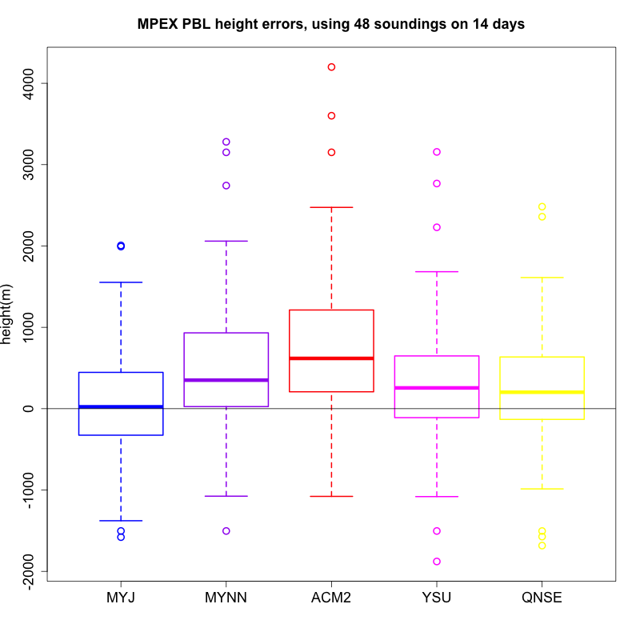
This figure is from an analysis of WRF model member errors for CAPE from the Mesoscale Predictability Experiment of 2013. Along with Dr. Russ Schumacher at Colorado State, we pieced together various member ensembles and compared the predicted values of CAPE versus observed values. Each of the circles outside of the box-and-whisker plots indicate the lower and upper 25% of data points.

A figure you admire for graphical reasons (paste, explain):

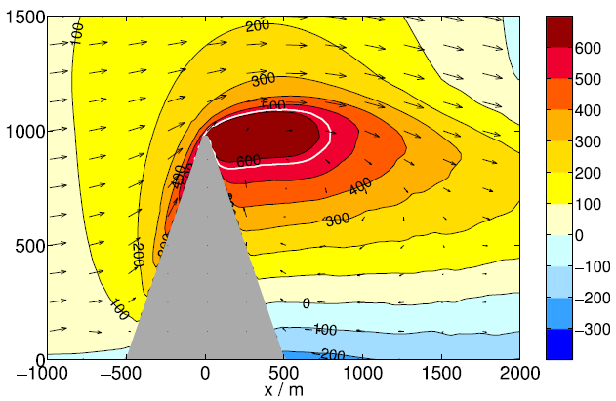

This figure was used in Schappert and Wirth (2015) to describe the flow of air parcels over a mountain feature and its subsequent role in orographic clouds. What is really interesting about this figure is how easy to read and understand it is. The clearly defined color bar let me visualize the cloud heights much better than a traditional black and white image, plus it is simply an impressive picture.

A figure you admire for content reasons (paste, explain):
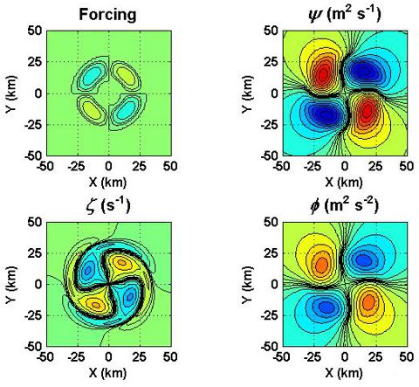

This is a figure cited from Cotto et al., (2013) regarding vortex rossby waves in a tropical cyclone. In short, various variables are discussed here including the streamfunction, vorticity, and geopotential changes with distance. It is such an information-packed figure, which lends itself for a great degree of discussion in the manuscript.

A figure you are puzzled about or intrigued by (paste, explain why its puzzling):

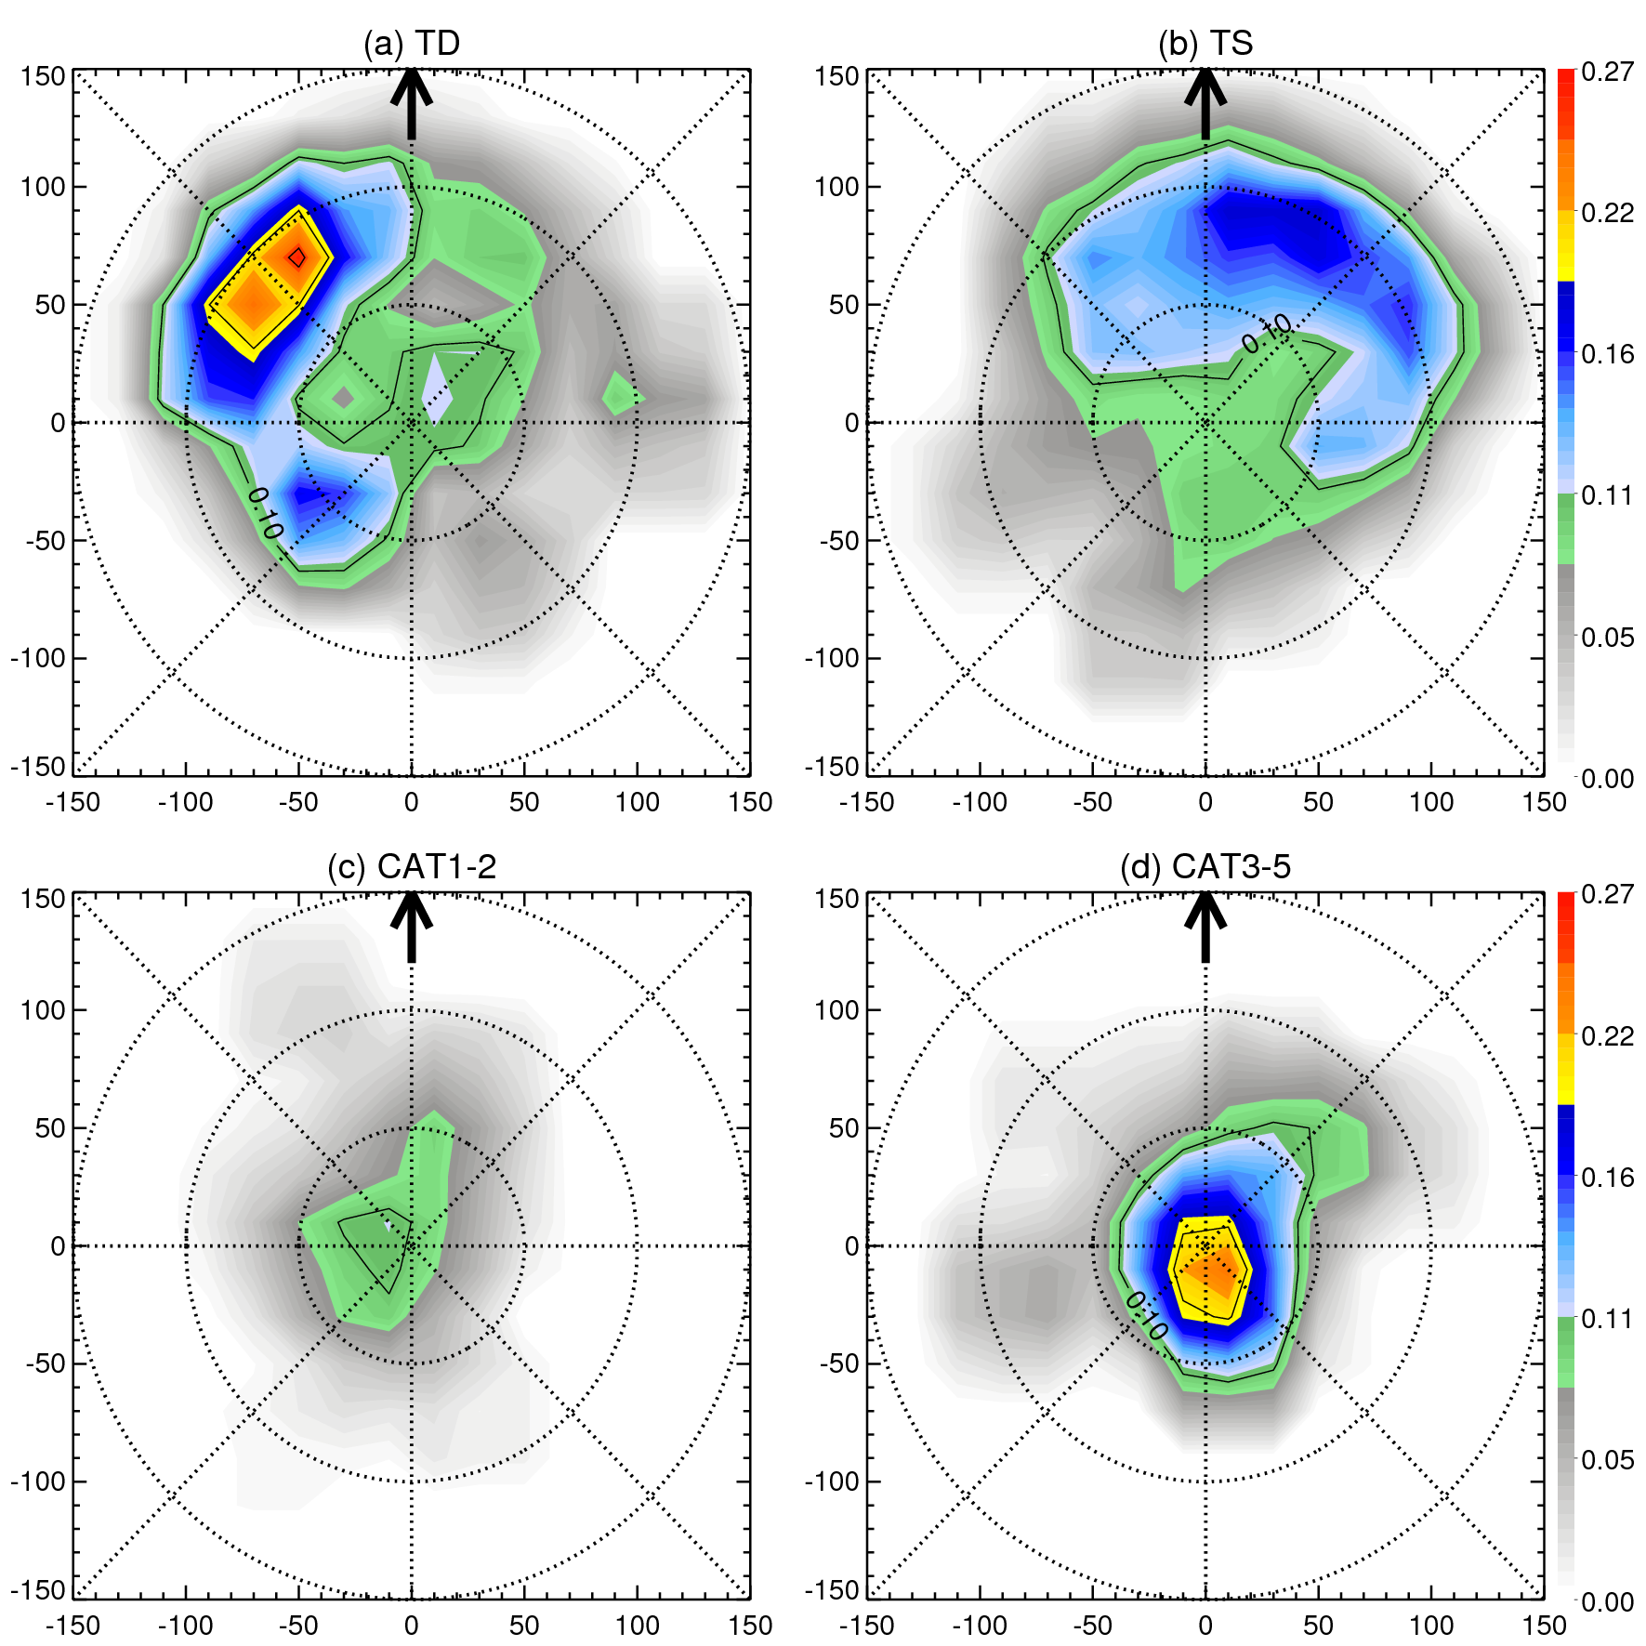

This was a figure I created as part of my undergraduate thesis which details the correlation coefficient (CC) between lightning pixels and raining pixels as observed by TRMM 2A12. Even to this day, I am still confused as to why the correlation coefficient between the two variables is so sporadic locations for tropical depressions and storms while category 1-2 and 3-5 cyclones focus more on the center. In particular, I question why the category 1-2 CC is low compared to the other categories in the plot.

Favorite ADA-related Web site or software not mentioned in course materials so far:

One of my other favorite ADA websites is the Environmental Simulations Incorporated page (http://www.groundwatermodels.com/ESI_Software.php). They have useful programs that I used during my undergraduate hydrogeology principles course at FIU and it connects to some of the issues facing low-level cities such as ours in terms of groundwater flow and aquifer behavior.

Initial brainstorming thoughts on a possible topic or ingredients for your term project. You might as well choose your research or something related to your other coursework, so you can double-count the effort and do better work instead of just more work. Any or all of the following thought-provokers may be your springboard. Again, don’t worry about impressing or grading or anything else, just help me (and us all, we will look these over on screen in class) understand where you’re at and your interests.

Preliminary thoughts for the term project involve me building on the general idea for my Ph.D. research. I would like to analyze global extreme precipitation events by combining the datasets from the MERRA and TRMM satellites into one comprehensive set in which it should be easier to find data and the coverage area be more expansive.

Your application: what behavior of what system might you be trying to characterize, or compare to what other system or model or forecast?

In this project, we are trying to determine causalities and predictability of certain extreme precipitation events such as those found during the Asian Monsoon or as a consequence of “atmospheric rivers” using simulations from the WRF model. In addition, we hope to build on a set of different case studies from extreme precipitation events so that we can analyze differences between well-analyzed and poorly-analyzed or poorly-represented cases.

Your data: what dataset(s) might contain the information you would like to explore or address? Feel free to use this as a springboard for a conversation with your advisor.

The datasets that I am currently using provide a great deal of information into what we are trying to visualize in our investigations. The MERRA and TRMM total precipitation datasets span from about 1997-2013 and so that should provide ample information for us to visualize and interpret plenty of case studies.

Your analysis: what kinds of questions do you imagine you will ask about the system or the datasets? What would constitute an answer or an addressing of the issue? What kinds of figures would you like to create?

I am highly sure that one of the questions will involve something about the different variables that go into the datasets and how to retrieve them in any programming language. To answer this, understanding how different variables are called in the most efficient way possible would help to address this point. The end goal is for me to develop figures that are not only aesthetically appealing and easy to read but also conveying significant amounts of information in the most concise way possible.

